REPRO PROCESS IN SYSTEM

OVERVIEW
Update repro status in the system after proof print approved by customer and create engraving protocol to production to engrave cylinder.

RESPONSIBILITY
Repro dept. (Lee, Vincent & Alex Ngai will have authority to update the information.)

PROCESS PROCEDURE
On screen below, select the job number to be update and go to field repro status and click the field. A pop up window will come out “Edit approval pending” change the status to approved and save. A warning message will pop up and click “Yes”. The job will be transfer to Engraving progress. We will not able to see this job again in this screen, it will only appeared in engraving progress.

4.1) PROGRESS – REPRO – SCREEN VIEW
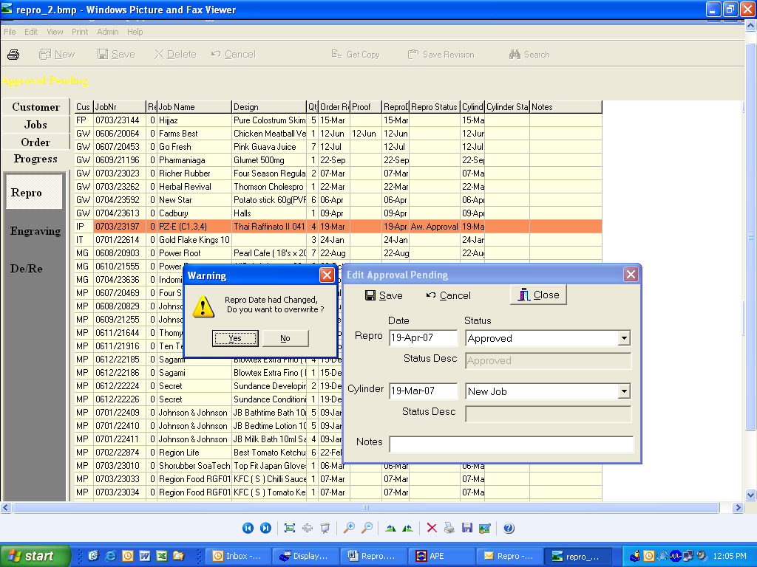

After update the status, go to next screen “JOBS-ENGRAVING” to create engraving protocol.

2.3) JOBS – ENGRAVING – INPUT SCREEN

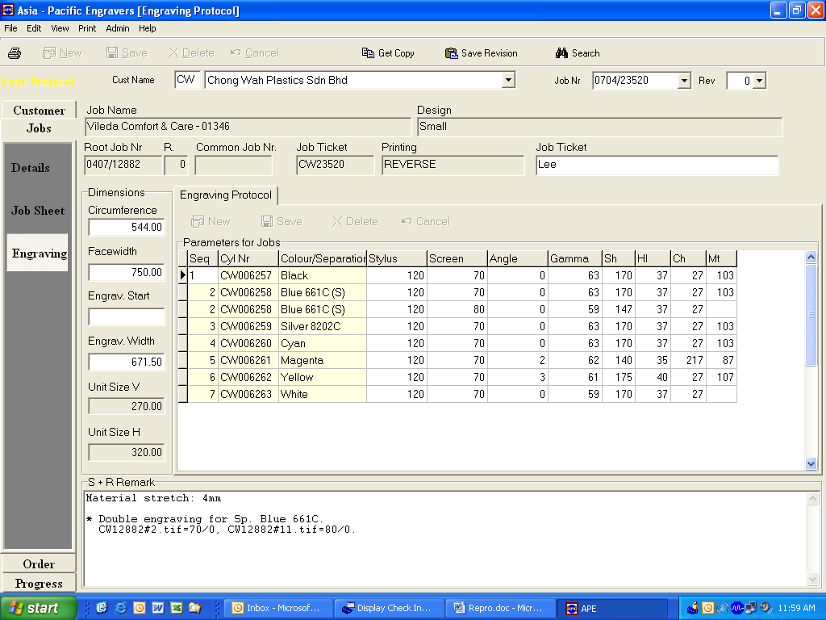

Enter the information in the circle column for each cylinder, the last 4 column are pre-set formula field but it can be change manually if the calculation does not matched the requirement.

After enter the information. Go to PRINT > ENGRAVING PROTOL to print out the engraving protocol.

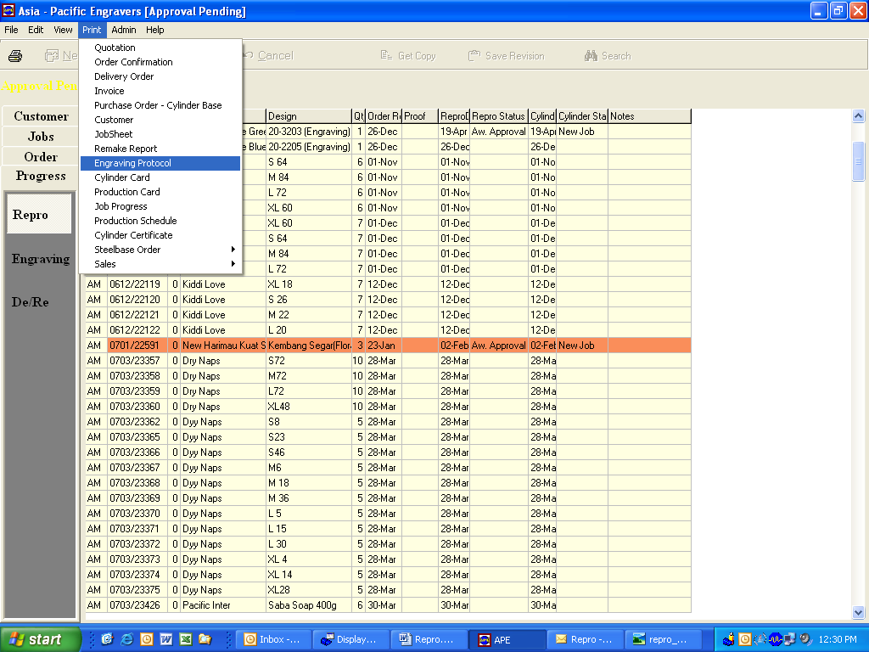
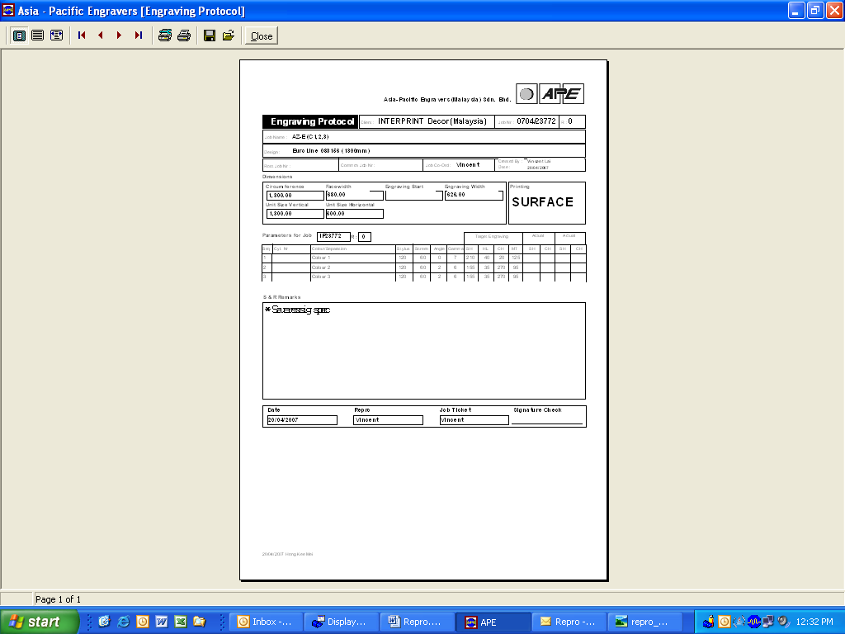

After the engraving protocol print out, go to scrren “PROGRESS – ENGRAVING” to change the repro status to “Job Ticket OK”.

4.2) PROGRESS – ENGRAVING – SCREEN VIEW
